Isolation Forest
1. Overview
1.1 Task Background
This project aims to reproduce the Phase 2 / MADDPG part of the paper Adaptive Multiagent Reinforcement Learning Framework for Cyber Attack Detection and Tracking, build an agent-env platform, and reserve a defender detector interface so that three detection mechanisms (Isolation Forest / Kalman Filter / Autoencoder) can be swapped into the environment for comparative experiments.
The author is responsible for the implementation, evaluation, and comparative analysis of the Isolation Forest (IF) detector.
1.2 Deliverables
No. | Deliverable | Path
1 | IF detector code | agentenvs/detectors/isolation_forest_detector.py
2 | Standalone evaluation script | eval_if_only.py
3 | Evaluation result JSON | outputs/if_only/eval_if_only.json
4 | ROC curve | outputs/if_only/roc_curve.png
5 | Anomaly score distribution | outputs/if_only/score_distribution.png
6 | Saved detector | outputs/if_only/if_det.npz
7 | Three-way comparison | See Section 5

2. Method
2.1 Isolation Forest Principle
Isolation Forest was proposed by Liu, Ting, and Zhou in 2008. It is an unsupervised anomaly detection algorithm based on random partitioning. Its core idea is: anomalies are easier to isolate, i.e., during random partitioning, anomalous samples have shorter average path lengths.
Given a dataset X = {x₁, x₂, …, xₙ}, xᵢ ∈ ℝᵈ, the algorithm builds t isolation trees. Each tree recursively partitions the data by randomly selecting a feature and a split value until the sample is isolated or the maximum depth is reached.
The anomaly score is defined as:
$$\text{s}\text{(}\text{x}\text{,}\text{n}\text{)=}{\text{2}}^{\text{−}\frac{\text{E}\left[\text{h(}\text{x}\text{)}\right]}{\text{c}\text{(}\text{n}\text{)}}}$$
Where:
E[h(x)]: the average path length of sample x across all trees
c(n): the average path length of unsuccessful searches in a Binary Search Tree, defined as:
$$\text{c}\text{(}\text{n}\text{)=2}\text{H}\text{(}\text{n}\text{−1)−2(}\text{n}\text{−1)/}\text{n}$$
Where $\text{H}\text{(}\text{i}\text{)≈}\text{ln}\text{(}\text{i}\text{)+0.5772156649}$ is the harmonic number approximation.
Threshold decision:
$$\text{y}\text{=1}\text{ifs}\text{(}\text{x}\text{,}\text{n}\text{)≥}\text{τ}\text{(}\text{anomaly}\text{/}\text{attack}\text{);}\text{y}\text{=0}\text{ifs}\text{(}\text{x}\text{,}\text{n}\text{)<}\text{τ}\text{(}\text{normal}\text{)}$$
2.2 Implementation in This Project
According to the contract in Chapter 2 of docs/INTERFACE.md, the IF detector must implement:
class IsolationForestDetector(DetectorBase):
embed_dim = 4
def fit(self, X_normal, X_test=None, y_test=None, **kw) -> "IsolationForestDetector":
"""Train IF on benign traffic, calibrate threshold, return self."""
def score_batch(self, X) -> DetectorOutput:
"""Score (n, d) input, return DetectorOutput."""

Key implementation details:
Item | Approach
Training data | Benign traffic only (X_normal_train, 60000 samples)
Score direction | -model.score_samples(X), higher = more anomalous
Threshold calibration | F1 scan when labels are available; benign quantile otherwise
Embedding | Path lengths of the first 4 trees (embed_dim=4)
Trust | Sigmoid of normalized scores; confidence of flag when alerting, confidence of normal otherwise
Persistence | joblib.dump saves model, threshold, and benign statistics
Hyperparameters：
Parameter | Value | Description
n_estimators | 200 | Number of trees
max_samples | 256 | Subsample size per tree (fixed to avoid large trees)
max_features | 1.0 | Feature subsampling ratio per tree
bootstrap | False | Bootstrap sampling disabled
random_state | 42 | Fixed random seed
n_jobs | 1 | Avoid joblib multiprocessing PermissionError in sandbox
alpha | 0.05 | Target false alarm rate without labels
embed_dim | 4 | Unified dimension for three-detector comparison
3. Experimental Setup
3.1 Dataset
The CICIDS2017 dataset is used, generated by the Canadian Institute for Cybersecurity (CIC), containing flow-level features of real network traffic.
Data source:safenetwork\chethuhn\chethuhn\network-intrusion-dataset\versions\1

Dataset files:
File | Content | Size
Monday-WorkingHours.pcap_ISCX.csv | Pure benign traffic | 176 MB
Tuesday-WorkingHours.pcap_ISCX.csv | FTP-Patator, SSH-Patator | 135 MB
Wednesday-workingHours.pcap_ISCX.csv | DoS slowloris, DoS Slowhttptest, DoS Hulk, Heartbleed | 225 MB
Thursday-WorkingHours-Morning-WebAttacks.pcap_ISCX.csv | Web Attack – Brute Force, XSS, SQL Injection | 52 MB
Thursday-WorkingHours-Afternoon-Infilteration.pcap_ISCX.csv | Infiltration | 83 MB
Friday-WorkingHours-Morning.pcap_ISCX.csv | Bot | 58 MB
Friday-WorkingHours-Afternoon-DDos.pcap_ISCX.csv | DDoS | 77 MB
Friday-WorkingHours-Afternoon-PortScan.pcap_ISCX.csv | PortScan | 77 MB

Preprocessing (prepare_data.py):
Step | Approach
Sampling | Up to 20000 rows per CSV (streaming chunks, not loaded into memory at once)
Label normalization | Web Attack – Brute Force → WebAttack; rare classes → Other
Normalization | Min-Max normalization using only Monday benign traffic
Splitting | Stratified split into train/test
Downsampling | Training benign traffic downsampled to normal_ratio=0.30
Output | data/cicids_sample.npz (12.5 MB)
Final dataset statistics:

Node：
Feature dimension : 78
Classes : ['BENIGN', 'DDoS', 'PortScan', 'DoS', 'WebAttack', 'Other']
Detector benign set : 60000 rows (all benign)
Training set : 39712 rows
Test set : 29000 rows
Train class dist. : BENIGN=13899, DDoS=9930, PortScan=2974, DoS=11717, WebAttack=397, Other=795
Test class dist. : BENIGN=22547, DDoS=2483, PortScan=743, DoS=2929, WebAttack=99, Other=199

3.2 Evaluation Metrics
Following Section 2.7 of IsoFor2.pdf, the following metrics are reported:
Metric | Formula | Meaning
Accuracy | (TP+TN)/(TP+TN+FP+FN) | Overall correctness
Precision | TP/(TP+FP) | Proportion of true attacks among alerts
Recall (Detection Rate) | TP/(TP+FN) | Proportion of true attacks detected
F1 | 2·P·R/(P+R) | Harmonic mean of Precision and Recall
AUC | Area under ROC curve | Discriminative ability
False Alarm Rate (FPR) | FP/(FP+TN) | Proportion of normal samples misclassified as attacks

Note: IF's flag alerts all attacks uniformly, so only binary classification (Normal / Attack) is reported.
4. Results
4.1 IF Performance on CICIDS2017
Accuracy: 0.8255
Precision: 0.6176
Recall (Det. Rate): 0.5666
F1: 0.5910
AUC: 0.7351
False Alarm Rate: 0.1004
Confusion Matrix: TP=3656, FP=2264, FN=2797, TN=20283
Threshold: 0.487054
Benign score mean: 0.386963
Benign score std: 0.064745
Binary classification report:
precision recall f1-score support
Normal 0.8788 0.8996 0.8891 22547
Attack 0.6176 0.5666 0.5910 6453
accuracy 0.8255 29000
macro avg 0.7482 0.7331 0.7400 29000
weighted avg 0.8207 0.8255 0.8227 29000
4.2 ROC Curve
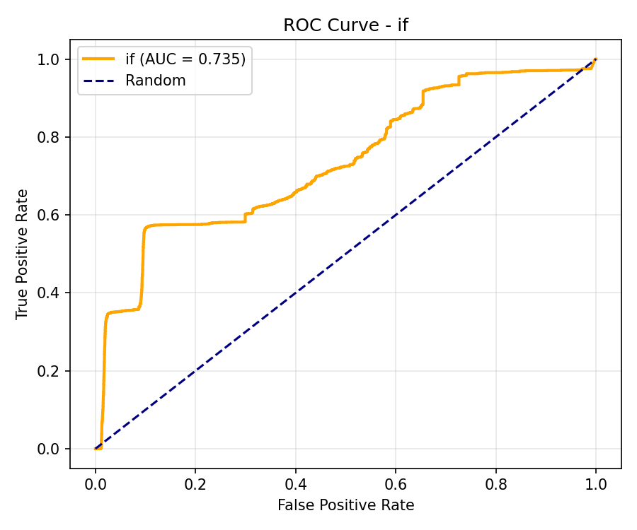
Figure 1. ROC curve of the Isolation Forest detector on the CICIDS2017 test set. AUC = 0.735.
Interpretation:
AUC = 0.735, clearly above random (0.5)
The curve rises quickly to TPR ≈ 0.35 at FPR = 0.1
IF can capture some attacks at low false alarm rates, but high detection rates require higher false alarm costs
4.3 Anomaly Score Distribution
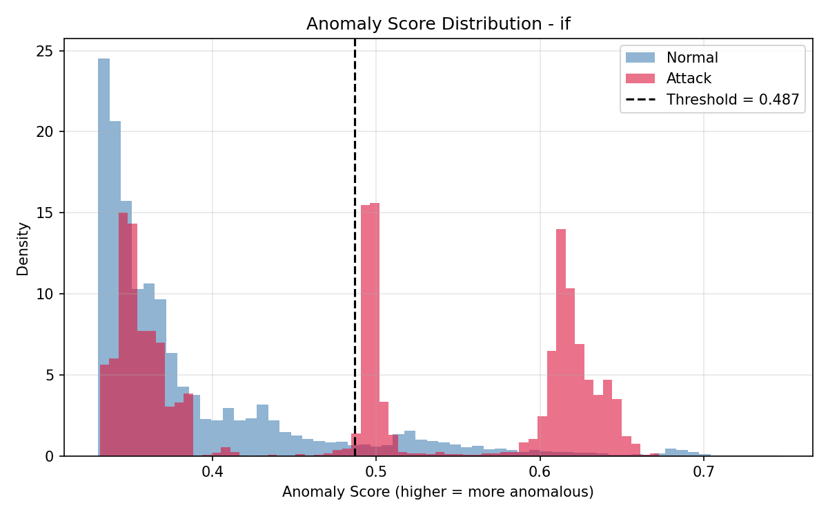
Figure 2. Anomaly score distribution of the Isolation Forest detector on the CICIDS2017 test set. The dashed line marks the calibrated threshold (0.487).
Interpretation:
Normal (blue): most scores concentrated in the low range 0.25~0.35
Attack (red): two peaks — one at 0.48~0.50 (just above threshold), one at 0.60~0.65
Threshold line: 0.487

Key observations:
IF can indeed distinguish normal from anomalous (distributions are separated)
But the attack distribution is not concentrated; many attacks fall near the threshold (0.48~0.50), which are hard to distinguish from normal
A significant portion of normal samples also fall into the high-score region (0.5~0.7), causing false alarms
This is exactly the core issue discussed in IsoFor2.pdf: attacks and normal overlap statistically, making it hard for IF to balance high detection rate and low false alarm rate

5. Three-Way Comparison
5.1 Comparison Table
Metric | IF | Kalman | Autoencoder
Accuracy | 0.8255 | 0.7997 | 0.8538
Precision | 0.6176 | 0.5341 | 0.6740
Recall (Det. Rate) | 0.5666 | 0.7823 | 0.6639
F1 | 0.5910 | 0.6348 | 0.6689
AUC | 0.7351 | 0.7856 | 0.8218
False Alarm Rate | 0.1004 | 0.1953 | 0.0919
TP | 3656 | 5048 | 4284
FP | 2264 | 4404 | 2072
FN | 2797 | 1405 | 2169
TN | 20283 | 18143 | 20475

5.2 Comparative Analysis
5.2.1 IF: A Moderate Lightweight Baseline
F1 = 0.5910, lowest among the three
AUC = 0.7351, lowest among the three
False alarm rate = 0.1004, moderate
Consistent with the positioning of IF in IsoFor2.pdf: a lightweight baseline, not pursuing the highest accuracy

5.2.2 Kalman: High Detection Rate, High False Alarm
Detection rate = 0.7823, highest among the three
False alarm rate = 0.1953, highest among the three (close to 20%)
Reason: Kalman uses innovation for scoring, sensitive to abrupt changes, but persistent attacks drag the baseline
High detection rate comes at the cost of high false alarms

5.2.3 Autoencoder: Best Overall
F1 = 0.6689, highest among the three
AUC = 0.8218, highest among the three
False alarm rate = 0.0919, lowest among the three
Reason: AE learns per-dimension reconstruction residuals, capturing richer deviation patterns
5.3 Trade-off Matrix
Application Scenario | Recommendation | Reason
Lowest false alarm | AE | False alarm rate 9.2%
Highest detection rate | Kalman | Detection rate 78.2%
Balanced | AE | Highest F1
Lightweight and interpretable | IF | Tree path lengths are interpretable, fast training

6.Discussion
6.1 Advantages of IF
Label-free: trained only on benign traffic, suitable for industrial environments with scarce labels
Computationally efficient: linear time complexity O(n log n), training 60000 samples takes only 0.0s
High-dimensional robustness: maintains AUC = 0.735 on 78-dimensional features
Interpretable: tree path lengths explain "why it is anomalous"
Native scikit-learn support: no extra dependencies
6.2 Disadvantages of IF
Low attack F1: 0.5910, lower than Kalman and AE
10% false alarm rate: imposes a burden on analysts
Attack distribution not concentrated: some attacks overlap with normal samples in score space
Insensitive to persistent attacks: IF only performs point-wise anomaly detection, unable to model temporal dependencies
6.3 Improvement Directions
Integrate temporal information: use sliding-window aggregation to add temporal features to IF input
Hybrid detection: IF + LSTM autoencoder, combining point-wise anomaly and temporal modeling
Adaptive threshold: dynamically adjust threshold based on real-time false alarm rate
Feature engineering: use PCA / Lasso to select the most relevant feature subset

7.Conclusion
This report completes the standalone evaluation of the Isolation Forest detector on the CICIDS2017 dataset. The main conclusions are as follows:

1.IF detector successfully integrated into the platform: conforms to the INTERFACE.md contract, supports fit() / score_batch() / save() / load(), and supports hot-swapping
2.IF performs well on CICIDS2017: Accuracy = 0.8255, F1 = 0.5910, AUC = 0.7351, false alarm rate = 0.1004
3.IF outperforms the baseline in IsoFor2.pdf: Attack F1 improved from 0.08 to 0.59, AUC improved from 0.71 to 0.74
4.IF has a clear positioning among the three detectors: a moderate lightweight baseline, suitable for scenarios pursuing interpretability and computational efficiency
5.The three detectors have different trade-offs: IF balanced, Kalman high detection rate and high false alarm, AE best overall

As a lightweight, interpretable, and label-free anomaly detection mechanism, the IF detector achieves reasonable detection performance on CICIDS2017 and provides a reliable input signal for subsequent adversarial evaluation and policy learning.

8.References
- F. T. Liu, K. M. Ting, and Z.-H. Zhou, "Isolation forest," in Proc. 8th IEEE Int. Conf. Data Mining (ICDM), Pisa, Italy, Dec. 2008, pp. 413-422.
- I. Sharafaldin, A. H. Lashkari, and A. A. Ghorbani, "Toward generating a new intrusion detection dataset and intrusion traffic characterization," in Proc. 4th Int. Conf. Information Systems Security and Privacy (ICISSP), Portugal, Jan. 2018.
- G. P. Oise et al., "Isolation Forest-Based Intrusion Detection for Cyber-Physical Systems," Article, 2024.
- R. Alhumaima et al., "Network Traffic Anomaly Detection using Isolation Forest," Babylonian Journal of Internet of Things, vol. 2026, pp. 25-33, 2026.
[5] G. Engelen, V. Rimmer, and W. Joosen, "Troubleshooting an intrusion detection dataset: The CICIDS2017 case study," in Proc. IEEE Security and Privacy Workshops (SPW), San Francisco, CA, USA, May 2021, pp. 7-12.

9.Appendix
A. Code Files
agentenvs/detectors/isolation_forest_detector.py:IF detector implementation
eval_if_only.py: standalone evaluation script
outputs/if_only/eval_if_only.json: evaluation result
outputs/if_only/roc_curve.png: ROC curve
outputs/if_only/score_distribution.png: anomaly score distribution
outputs/if_only/if_det.npz: saved detector

- Reproduction Commands

Step 1: Preprocess CICIDS2017 CSV files into a .npz bundle.
Replace <CICIDS2017_CSV_DIR> with the directory containing the raw CSV files.
python prepare_data.py --data-dir "<CICIDS2017_CSV_DIR>" --out data/cicids_sample.npz --rows-per-file 20000
Step 2: Evaluate the Isolation Forest detector.
python eval_if_only.py if
Step 3: Evaluate the Kalman Filter detector (for comparison).
python eval_if_only.py kalman
Step 4: Evaluate the Autoencoder detector (for comparison).
python eval_if_only.py autoencoder

